**AMAZON S3 OBJECT ENCRYPTION**

An object in s3 can be encrypted in the following ways as is shown below:

**THE DIFFERENT ENCRYPTIONS ARE DESCRIBED AS BELOW:**

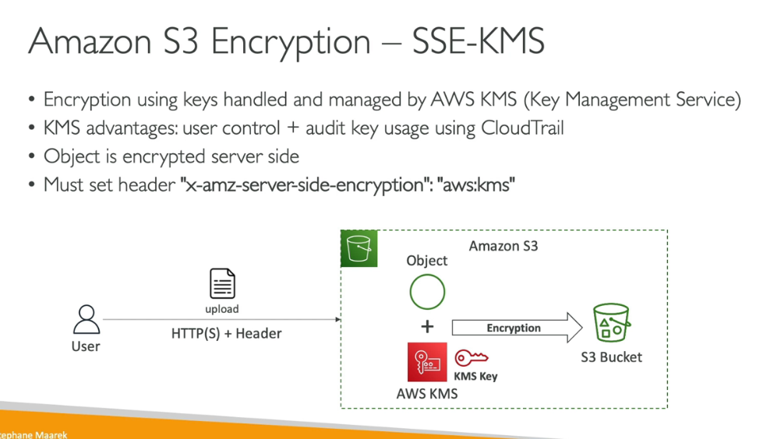

There is a limitation with the kms encryption as each time we will have to make a call to the kms and thus there will be some quota on the number of kms calls per region and suppose in some cases there the quota is destroyed but you may face throttling in this case.

